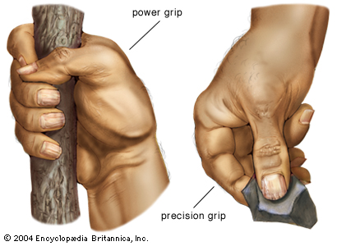
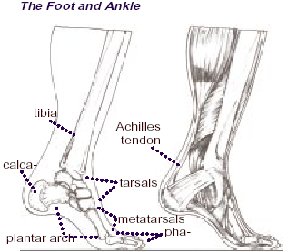
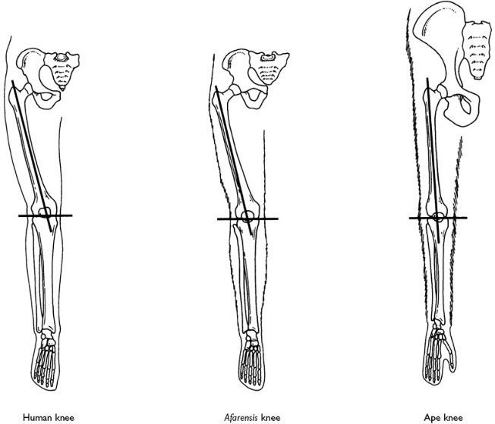
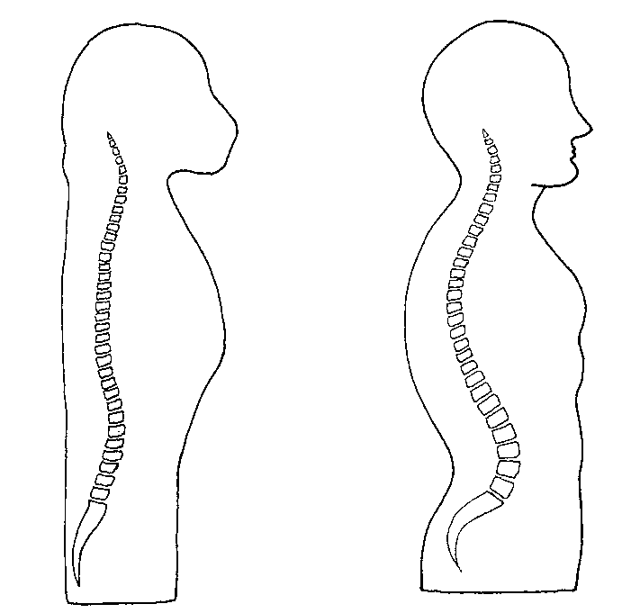
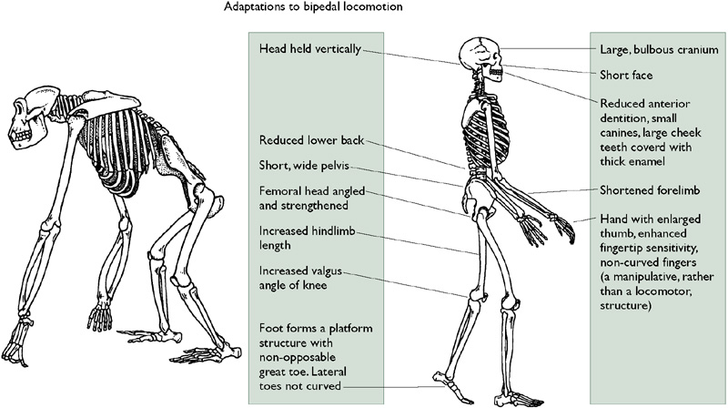
- The outer condyle of the human knee is larger than the inner one as it takes the weight.
- In apes the reverse is true.
- Our knee can lock and keep the legs straight so our weight is supported by the bones.
- We can stride with less energy use than an ape whose legs are bent and muscles must be used to support their weight. They must also waddle.
In humans and other bipedal hominins the knee is angled in towards the midline of the body, bringing it under the centre of gravity.
Valgus Angle
The human spine is said to be ‘S-shaped, but has 4 curves that bring the centre of gravity above the pelvis
- The longer, more mobile human thumb can be opposed to all of our fingers to give us the precision grip. This, along with our more sensitive finger pads enables us to manipulate objects better than apes.
In apes it is not.

